Project : | General
Version : | 0.02
File prospector for NOR FS
Reported :
Verified :
Approved :

Revision History
Rev | Date | Author | Description
0.01 | October 21, 2008 | Owen Lee | Initial version for v1.0.0.0
0.02 | January 25, 2010 | Joe Su | - Make compatible with DWLWin V3.5.6.5  - Allow passing sector number of RAI Object through command-line.

Table of Contents
Revision History 2
Table of Contents 3
1 Document Scope 4
1.1 Purpose 4
1.2 Abbreviations and Terms 4
1.3 References 4
2 Overview 5
2.1 Flow chart 5
2.2 Manual 5
2.2.1 Extract binary from target 6
2.2.2 Run FileProspector.exe 7

Document Scope

Purpose
File prospector is the debugging tool for extracting the storage information on NOR flash. It outputs all the RAI objects with both active and deleted status. And the NOR file system will also be dumped into PC environment, include file/directory tree and file content.

Abbreviations and Terms
FMS | Flash Memory Services
RAI | Random Access Interface

References

Overview
This chapter gives the instruction of File prospector usage.

Flow chart
FileProspector.exe is a console application in WIN32 environment. The input is the load on target, read from DWLWin (After version 3.5.6.5). The output will in the relative directory with “Dump” folder name.
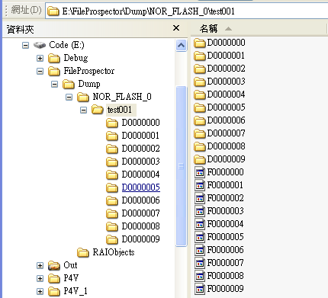
File Prospector
Upload.bin
Upload_info.bin

Manual
The steps for using File Prospector are in the following:
- Extract binary from target
- Run FileProspector.exe to dump File tree and RAI information to PC

Extract binary from target
The output in this step is
- Upload.bin: The raw data of the target load.
- Upload_info.bin: The geometric information for Upload.bin.

Notice: the version of DWLWin should be newer than 3.5.6.5.

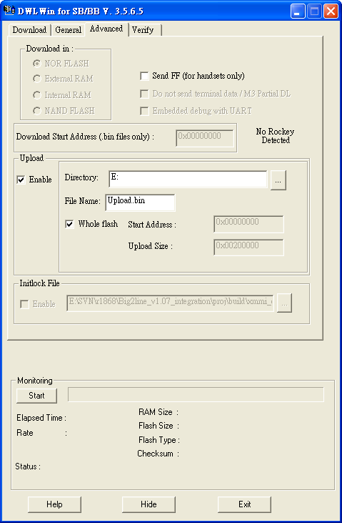
Enable “Upload” & “Whole flash” feature
Press “Start” button to read the whole flash for analysis

Run FileProspector.exe
After step 1, we can get Upload.bin and Upload_info.bin. They are the input for FileProspector.exe. Here is the content for the batch file, run.bat for launch FileProspector.exe quickly.
FileProspector.exe Upload.bin Upload_info.bin [N_{sector}]

N_{sector}: Optional. If not specified, its default value is 7.
We can put these two files in the same folder with FileProspector.exe
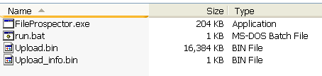

Run the following command in command line window, you can see the intermediate process, like this:
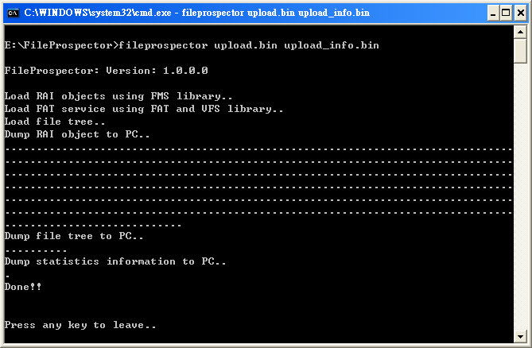
Then the file tree and RAI objects will be dumped
